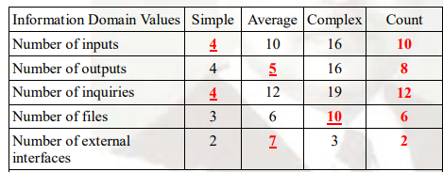
Q. Considering the following information for a software development project to answer the question given below
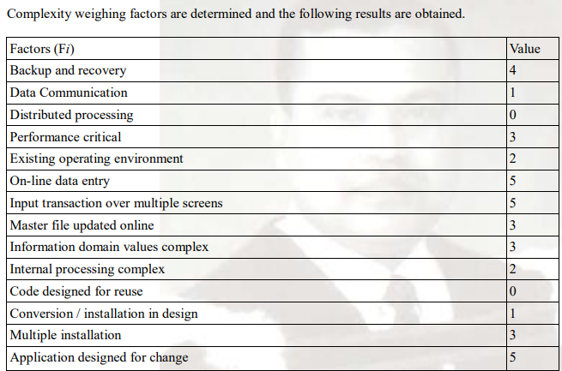

For historical data, productivity is 55.5 FP person-month and development cost is $8000 per month.
Now calculate the Estimated number of FP,person-month, total cost ,cost per FP.

